Main Feature
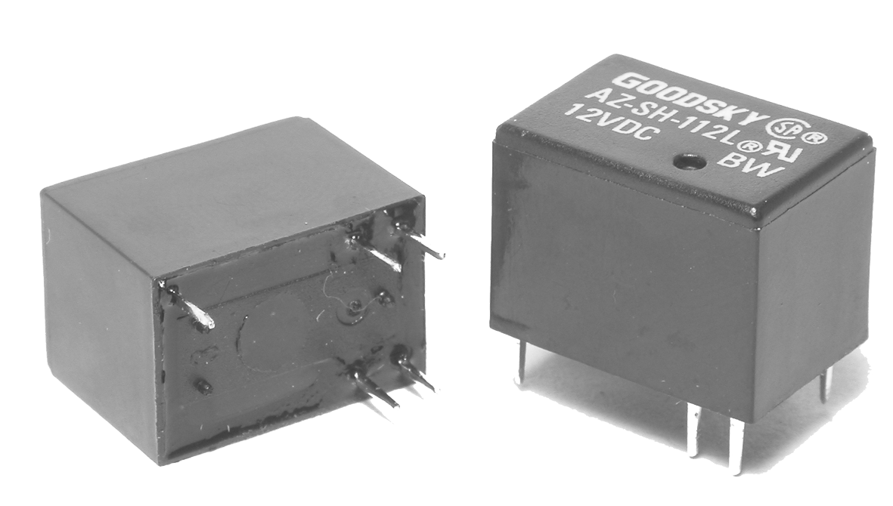
- AZ Relay Performs high reliability in dry circuit.
- High density design is available on P.C. Board with size of 10.4x15.4x11.2 in mm and the weight of 3.5 grams.
- The Employment of 2.54mm terminal pitch is equal to I.C.’s terminal pitch.
- The low power consumption of AZ-L type and general power consumption type of AZ-D are prepared for user’s wide selection.
- Complete protective construction is designed from dust and soldering flux. In addition, the plastic sealed type is prepared for washing procedure.

Application

Telecommunication, Domestic Appliances, Office Machine, Audio Equipment, etc.

Contact Rating

- Nominal Load (Resistive Load Cosφ=1)
Contact Capacity 1A at 120VAC.
1A at 24 VDC.
Rated Carrying Current 1A.
Max. Allowable Current 1A.
Max. Allowable Voltage AC 120V, DC 60V.
Max. Allowable Power Force130 VA, 30W.
Min. Switching Load DC 1V, 1mA.
- Contact Material Ag Alloy.
- Contact Form SPST & SPDT.

Performance (at Initial Value)

- Contact Resistance 100mΩ Max.@100mA,
6VDC
- Operate Time AZ-D 5 mSec. Max.
AZ-L 10mSec. Max.
- Release Time 4 mSec. Max.
Dielectric Strength :
Between Coil & Contact 500VAC at 50/60 Hz
for one minute.
Between Contacts 500VAC at 50/60 Hz
for one minute.
- Surge Resistance 1,000V (between coil
& contact 1.2x50μSec.)
- Insulation Resistance 100 Mega Ω Min. at
500VDC.
- Max. On/Off Switching :
Electrical 30 Ops per Minute.
Mechanical 300 Ops per Minute.
- Temperature Range -30 ~ 55°C (D Type)
-30 ~ 75°C (L Type)
- Humidity Range 45~85% RH.
- Coil Temperature Rise 43°C Max. (D Type)
25°C Max. (L Type)
- Vibration :
Endurance 10 to 55 Hz dual
amplitude width 1.5mm.
Error Operation 10 to 55 Hz dual
amplitude width 1.5mm.
- Shock :
Endurance 500 m/S² Min.
Error Operation 100 m/S² Min.

- Life Expectancy :
Mechanical 10⁷ Operations at No
Load condition.
Electrical 10⁵ Operations at Rated
Resistive Load.
- Weight About 3.5 g.

Safety Standard & Its File Number

- UL E141060
- CSA LR76598

Coil Specification (at 20°C)

Coil Sensitivity | Nominal Voltage (VDC) | Nominal Current (mA) | Coil Resistance (Ω±10%) | Power Consumption (W) | Pull-In Voltage (VDC) | Drop-Out Voltage (VDC) | Maximum Allowable Voltage (VDC)
AZ-D | 3 | 150 | 20 | Abt. 0.45 | 70%  Maximum | 5%  Minimum | AZ  130%
AZ-D | 5 | 89 | 56
AZ-D | 6 | 75 | 80
AZ-D | 9 | 50 | 180
AZ-D | 12 | 37.5 | 320
AZ-D | 24 | 18.8 | 1,280
AZ-L | 3 | 66.7 | 45 | Abt. 0.20 | 75%  Maximum | 5%  Minimum | 130%
AZ-L | 5 | 41.6 | 120
AZ-L | 6 | 33.3 | 180
AZ-L | 9 | 22.5 | 400
AZ-L | 12 | 17 | 700
AZ-L | 24 | 8.6 | 2,800

Ordering Information

AZ | - | SS | - | 1 | 12 | D | M
 |  |  |  |  |  |  |  | Contact Form: | Nil: One Form C  M: One Form A
 |  |  |  |  |  |  |  | Coil Type: | D: Standard DC Coil  L: High Sensitivity DC Coil
 |  |  |  |  |  |  |  | Coil Voltage: | 03: 3V, 05: 5V, 06: 6V, 09: 9V, 12: 12V, 24: 24V
 |  |  |  |  |  |  |  | Number of Pole: | 1: One Pole
 |  |  |  |  |  |  |  | Type of Sealing: | SS: Flow Solder Type  SH: Plastic Sealed Type
 |  |  |  |  |  |  |  | Type: | AZ

Classification

Model | AZ
Coil Sensitivity | Standard Type |  | High Sensitivity Type
Contact Form | 1C | 1A | 1C | 1A
Flow Solder Type | AZ-SS-1□□D | AZ-SS-1□□DM | AZ-SS-1□□L | AZ-SS-1□□LM
Plastic Sealed Type | AZ-SH-1□□D | AZ-SH-1□□DM | AZ-SH-1□□L | AZ-SH-1□□LM

Dimension
Reference Data

